**CHAPTER WEE CARE PROGRAM - OCTOBER 2018**

**Station 1: Blocking and Preparing your Gowns for Smocking**

**Presenter: *Barbara Meger***

1. Find ***center front*** of gown: (a) count pleats between front shoulder seams and divide number in half; *or* (b) gently spread gown front to flatten and fold to find center. ***Mark center valley*** with a pin or thread tack.
2. For *tailored boys’ gowns*, insert ***ribbon through casing*** and complete front vertical tucks/embellishments as desired.

A picture containing outdoor object

Description generated with high confidence

1. Gently spread and ***fan out gown*** until back edges form a ninety-degree angle. Be careful that bottom pleating threads do not come loose at edges.
2. Do NOT remove pleating threads from back edges.

**90 degrees**

1. ***Tie off bottom two threads*** at each side so that gown lays smoothly.
2. ***Tie remaining pleating*** threads loosely to allow room for smocking uppermost rows.

**C**

1. Follow center valley mark at top down to the bottom row and mark the two surrounding pleats with a pin. ***This is where smocking will begin.***
2. From smocking design, select the ***lowest level stitch*** in a motif (a heart, for example). Cut smocking thread twice the normal working length (36 inches). ***Do NOT knot!***
3. Insert needle, as if taking a stitch, through pleat just left of center. ***Pull through so that half of the thread is on each side of the pleat.*** Shift the long thread tail toward the top to get it out of the way. With thread down, stitch into pleat just right of center. Pull up, creating a down cable.
4. Smock to the end of the row, completing the motif if possible with 2-3 free pleats remaining. Do NOT tie off. ***Let thread hang until the first half of the row is stitched.***
5. Return to center and ***invert gown*** so that the bottom row is now on top. (Turn smocking design upside-down, as well.) Stitch across to the end of the row.
6. ***Leave two or three free pleats*** at the beginning and ending of the row at each side. It may be necessary to do a couple more stitches of the motif on each side. (It is possible that the number of free pleats on each side is not the same.) Once you are satisfied with the look, ***tie off stitching threads at each end of the row.***
7. Subsequent rows may start either at the center, as above, or at the end.
8. Once smocking is completed, ***remove pleating threads*** and ***insert ribbon through casing*** if not done earlier. Pull up ribbon and tie into a temporary bow. Spread and fan out gown as above with back edges forming a ninety-degree angle. ***Pin to ironing board and steam to block.*** Use this opportunity to ***press the gown*** before adding side seams and hem.

**CHAPTER WEE CARE PROGRAM - OCTOBER 2018**

**Smocking Your Wee Care Gown**

1. Threads: Use 2 strands of DMC, 1 strand of Perle Cotton, 2 of Overdyed floss. Use 2 strands of DMC Broder Threads, 2 strands of Cotton Floche. See samples.
2. Remember to Strip your threads if more than 1 strand.
3. Show which row to begin smocking stitch on. Have 3 rows of smocking for Tiny and Small gowns and 3 to 4 for large gowns.
4. Suggested starting rows (cable for neck only or trellis) OR follow smocking plate.
5. This is a good opportunity to try some different threads on your gowns.

**CHAPTER WEE CARE PROGRAM - OCTOBER 2018**

**Station 2: Construction of Gowns**

**Presenter: Joyce Ross**

1. Use a size 65 to 70 needle.
2. Set machine to do a zigzag stitch of 3.0 width, 1.0 length.
3. Make a French Seam (or a narrow serge edge). Should be no more than 3/8 inch wide when finished.
4. Sew wrong sides together with a narrow zigzag stitch. There will be no need to trim excess fabric because stitch will fall to the right of seam.
5. Press and turn. Sew right sides together, change to a Blind stitch foot (#10 Bernina) and place turned seam to the right of needle and use a straight stitch length of 2.0.
6. Press seam to back and press again from the front.
7. Various hem finishing can be done. Here is a simple one.
8. Turn raw edge 1 inch, press and turn again. Stitch with a 3.0 stitch. I do a knot in place or backstitch 2 stitches at both starting and ending positions. Add a decorative flair by doing a whip stitch over each stitch with 1 or 2 strands of the colored floss used on the gown.
9. Insert ribbon at neck if you haven’t done this during blocking.
10. Press your gown well, and return your clean gown into the plastic bag it came in.

**Station 2 … – Chapter Wee Care Program**

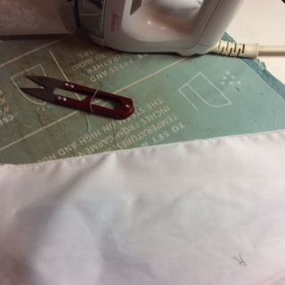

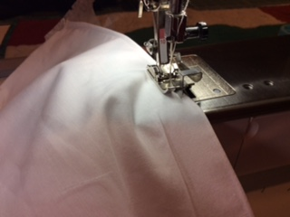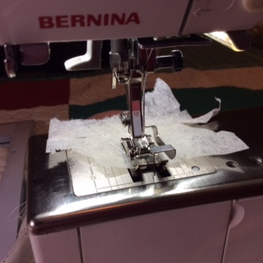

**Station 2 … – Chapter Wee Care Program**

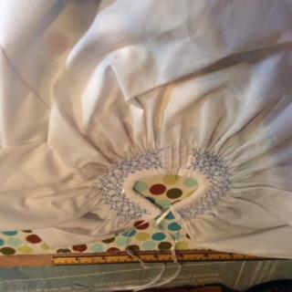

**CHAPTER WEE CARE PROGRAM - OCTOBER 2018**

**Station 3: Bonnets and Caps**

**Presenter: Jackie O’Neill**

**BONNETS**

1. Follow directions for **Bonnets** that are in the plastic bag.
2. Remove the first 2 pleats in each row, right and left side.
3. Tie off bonnet to about 4 inches or until the pleats are stacked side by side.
4. Smock 3 rows. You can use the enclosed smocking plate or your own design or a favorite.
5. Attach ribbons on middle of each side.
6. Return to the plastic bag it came in along with the instructions.

**CAPS**

1. Follow the instructions provided.
2. You may want to start with step 2 and after step 4 embellish with a decorative stitch around the outside of cap. (see sample).
3. If you want you can machine embroider a small duck or other appropriate design at the top front of cap.
4. Finish by following the directions sheet for steps 5 and 6.
5. Press cap.
6. Return to the plastic bag it came in along with the instructions.