March 2025

Dear Chesapeake Treasures,

Many of us are fresh off a few beautiful days at West River for the annual retreat. I always find this time so re-energizing and inspiring! Thank you to all those who ensured it was such a fun and well organized event, particularly Jo Shaw! Save the dates for next year – February 20-22/23, 2026! Registration will start at the June Potluck.

We have many exciting programs and activities planned for our members in the coming

months! Thank you to our organizers, Pat Conklin, Sandy Suhrie, Joyce Ross and Kathy Furth.

Also, thank you to the many of you who have volunteered or signed up to participate in these events.

First up is the March 15 convention favor workshop at the Edgewater Police Station. If you

haven’t let Sandy know you are coming, please let her know this week. She will be traveling

back to Maryland midweek. Bring your own lunch and a snack to share.

March 21 a group will be going to the 50th Anniversary Woodlawn Needlework show and

enjoying a delicious lunch put on by Nellie’s Needlers. A carpooling group will be meeting at

the Crofton Dollar Tree and leaving around 9 am. Let Joyce Ross know if you are coming and if you want to drive back with the carpool or if you will be driving on your own.

March 31 is the cut off date for registering for the fabulous Cork and Smocked handbag with

Jann Young to be held on May 3-4 at the Edgewater Police Station. Let Pat Conklin know if you need another registration form sent to you. She will have copies at the Program meeting this

Thursday.

Starting April 10, VP of Programs, Kathy Furth, will be introducing our program for the rest of

the year – Embroidered Ornaments. This program will be sure to inspire and challenge our

members. Thank you to all who have volunteered to teach a segment of this program series.

As always, your contributions are what make this chapter what it is! Thank you to those who

volunteer, who teach, who organize or who work in the background to make sure things

happen. You are what makes this group special!

Lindsay

**West River Retreat 2025 - Another Special Weekend with friends!**

Many thanks to Jo Shaw and her worker bees for hosting another fabulous retreat! We had 30 registered for retreat, with 29 able to attend. The set up and break down crews completed their tasks in record time! Many delicious Friday night dinner contributions were enjoyed. Fun games were organized by Marlene Mehn. Barbara Meger led a very creative and colorful program involving embellished embroidery stitches on ticking fabric to be used as a notebook cover or small zipper case. Joan Messinger provided a themed assortment of favors which included various sizes of indispensable clear rulers. Her elves, Cindy Kelleher and Ramona Jimeno, made adorable felt cases for the attendees to store the rulers in!

We had 11 members from the Chesapeake Treasures attending with others from Southern

Maryland Smockers, Martha Washington Chapter and Alexandria Fine Stitchers!

We also had guests from Tennessee, South Carolina, Michigan, West Virginia and Delaware. As always, I brought more projects to complete than I was able to get to but completely enjoyed the camaraderie and conversation!

What did I get done, well, I brought about 4 projects of which I finished 1 (a Pink Hollybush

Designs smocked Honey dress) and almost finished the bloomers for another. I inherited a

beautiful UFO which will be completed for the arrival of my newest granddaughter this

summer. I also found some precious patterns and fabrics in the destash and share piles.

The cutting mat donated by the Chesapeake Treasures was unrolled and “christened” at this

event. The old, very damaged mats were rolled up and marched to the dumpster, accompanied by the humming of Taps.

Meals were a time for mingling and chatting. Each meal was set with a backdrop of the

beautiful West River, treed coastline, blue skies, and wildlife. The chef did a wonderful job

providing us with a variety of delicious meals, and accommodating those with food

requirements. My favorites were waffles, marinated chicken thighs and fresh fruit. Let’s just

say, none of us went hungry.

Mark your calendars for next year’s retreat, February 20-22/23, 2026. Registration will open to Chesapeake Treasures members at the June 12 Potluck. It will open to returning non-members on August 15 and to all interested on September 15.

Hope to see you there next year!

Lindsay

**Birthdays – Happiest of Birthdays to our March and April Ladies**



[This Photo](https://www.flickr.com/photos/freakgirl/3273518391/) by Unknown Author is licensed under [CC BY-NC-ND](https://creativecommons.org/licenses/by-nc-nd/3.0/)

**March**

**Lauren Lyles Carolyn Dalton**

**April**

**Meghan Buchanan Sue Hoge**

**Peggy Hueston Karen Lang**

**Barbara Meager Joan Messinger**

**Dawn Watson**

***EDUCATION COMMITTEE***

The Chesapeake Treasures Education Committee is excited to announce registration is now opened for the Spring Program -- The Caribbean Cork Bag taught by Jann Young.  We hope you will join us on May 3-4, 2025, at the Edgewater Police Station.

The brochure with all the details and a few photos of this fabulous cork bag you will create have been emailed to members.

To whet your appetite here is a brief description of what you have to look forward to:

The project features this amazing new fabric in the form of a shoulder bag. The smocked insert will introduce you to a new design technique taken right from Swedish Huck weaving stitched with a bright and sunny overdyed pearl cotton.

Size of the Bag: 12" wide x 9" high x 4" deep

Choice of Color insert: Orange or Black

Kit Cost: $75

Program Cost: $100

Includes the instructor, Jann Young, for both Saturday and Sunday, lunch, snacks, beverages

The first 6-hour class will concentrate on learning the smocking technique, the following 3-hour class will be a demonstration on construction of the bag, and the remaining 3-hour will give you time to finish your project and ask Jann questions.

Registration is exclusively opened to Chesapeake Treasures until March 10.  On March 11, we will open the program up to other chapters.  We hope you will join in the fun, learn a new technique and for many, experience working with this new textile.

If you have questions, please contact Pat Conklin.  If you are unable to open the attached brochure, please let me know and I'll pop one in the mail to you.

Let's make this a weekend to remember.  The Education Committee looks forward to seeing you at the Chesapeake Treasures Spring Program.

Pat C.

New Embroidery Site

Featured on The Today Show this week was **PennyLinn.com**

Established in 2020, Penny Linn is a new kind of needlepoint store offering inspiration, education, essentials, and accessories to help anyone fall in love with the craft.

Their website is nice, lots of beautiful pictures, kits, tutorials, threads – a shopper’s dream!

My Destash Day

Spring Cleaning came early in January 2025. It may have been because I

couldn’t find anything in the fabric closets or, I just had a moment that

the chaos had to get under control. In any case, it is now done. The

ladies that went to the C.T. Retreat in West River received three large

bags of fabric I knew I would never use. I hope most of it will benefit a

new project. Below are before, and after pictures. Hope this will

inspirer more Fabric-a-holics. There should be a National “ destash

day”. I’m ready to start some Spring sewing.

**SIT AND STITCH SCHEDULE**

March 26

Meet at 12 noon at Panera in Waugh Chapel

Please text or email if you plan to come the week of the meeting.

Thanks, Joyce Ross

Mitzi received this gift for registering early for her SAGA dues. Congratulations!

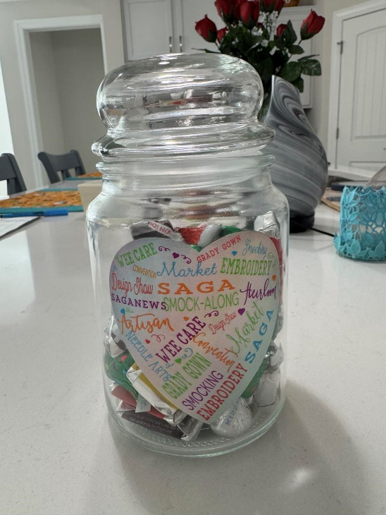

Attached with the newsletter is a Needle Guide from John James Needles. It was a free download. It has all the needles with a description and actual needle sizes.

SAVE THE DATE – West River Retreat – Feb 20 – 22/23, 2026

Spring Hospitality sign up - Please contact Marina Rutkowski to let her know what you will be bringing and for what meeting (drinks, sweet, savory)  rosamystica2011@protonmail.com

|  |  |  |  |
| --- | --- | --- | --- |
| Month | Beverage | Sweet | Savory |
|  |  | | |
| January |  |  |  |
| February |  |  |  |
| March | Carolyn | Kathy | Joyce |
| April | Joan Messinger | Mary Margaret |  |
| May |  |  | Carolyn |
| June | **POT LUCK - TBD** |  |  |

Meeting Dates for 2025

I am happy to report we have a new meeting location, the First Baptist Church of Crofton.

We are in the large central hall which will be partially set up for us each month. Depending on attendance we might need to put up an extra table or two and add more chairs. There is a large TV/monitor available for Charrise and our Zoom members ��

The church is located at 1690 Crofton Pkwy, Crofton, Maryland 21114. It is conveniently located just off the Crofton Parkway and is easily accessible from Route 3 as well as 450 and Davidsonville Road. For some of you it may even be within walking distance!

The parking lot is located just outside the entrance to the meeting space. It is a level lot.

We have the room from 5 pm – 8:45 pm each month - January – May, September – November.

March 13 - 5pm   First Baptist Church of Crofton

April 3 - 7pm Business Meeting by zoom – All are invited. Nominating Committee formed

April 10 - 5 pm   First Baptist Church of Crofton

May 1 - 7pm Business Meeting by zoom – All are invited. Committee Chairs please be prepared to report on your committee Presentation of Slate of Officers

May 8 - 5 pm   First Baptist Church of Crofton

June 5 - 7pm Business Meeting by zoom – All are invited

               Committee Chairs please be prepared to report on your committees

Vote on Slate of Officers

June 12 - Time TBD Spring/Summer Potluck dinner

   An alternate day may be selected if the group prefers to do lunch.

Please let Lindsay know if you would like to host

For the March 15th Workshop – please bring materials to make some bereavement envelopes.

**Bereavement/Memory Envelope**

You Tube video to the memory envelope can be found here <https://www.youtube.com/watch?v=R6uUCKthBd8>

Below are a few adjustments Joyce made to the YouTube demo

1. Quilting the outer fabric is optional.

2. All seams are 1/4 "

3. Ignore making the pocket on lining fabric. Skip to 9:34 time on video.

4. After 14:51,(time on video) topstitch should be no more than 1/8".

5. If you have snaps you can put them on or leave them off. I will attach it when returned. That's all there is to making these easy envelopes.

Officers of Chesapeake Treasures 2024/2025

Lindsay Carroll, President **Kathy Furth** , V. P. Programs

lindsaystitching@gmail.com kfurth59@hotmail.com

410-842-3773 443-540-8169

**Carolyn Dalton, V. P. Membership** **Lyn Leet, Secretary**

Dal0328@msn.com [leetmv@comcast.net](mailto:leetmv@comcast.net)

410-562-7544 443-994-4576

**Karen Lang, Treasurer**

Gklang99@gmail.com

717-487-8216

**www.chesapeaketreasures.org**. Carolyn has lots of information on our website. Be sure to check it out and let Carolyn know if you have anything to add.

***NOTE***: The SAGA President has a new email: sagapresident@smocking.org

SAGA—The Smocking Arts Guild of America - “Our purpose is to preserve and foster the art of smocking and related needlework for future generations, through education, communication, and quality workmanship.”

www.smocking.org